21st annual

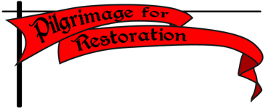
to the Shrine of Our Lady’s Martyrs at Auriesville, NY

September 23-25, A.D. 2016

Restoring true devotion to Mary, Mother of Mercy

Journey through majestic Adirondack forests sanctified by the blood of martyrs. Traditional Roman Liturgy every day. Confession, counsel and teaching from priests of solid faith. Fellowship & fun. Shuttles & TLC for the weary.

Something for everybody: youths, students, seniors. Family-friendly, kids love it! http://pilgrimage-for-restoration.org/schedules/

Can’t travel? Pray and participate from afar, or sponsor a pilgrim at
www.national-coalition.org/w/pilgrimage-without-travel.

Not yet sure you can make it? PRE-register to hold your place.
http://national-coalition.org/w/pre-registration-pilgrimage-2016

Register online, or send contact info with $95 check to NCCL - 621 Jordan Cir, Whitehall PA 18052. http://pilgrimage-for-restoration.org/registration/

Group & family rates available. DEEP discounts expire June 1.

Questions? pilgrimage.for.restoration@gmail.com 610/435-2634 http://pilgrimage-for-restoration.org
