25th Annual

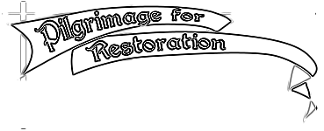
a traditional, walking pilgrimage
to the Shrine of Our Lady’s Martyrs at Auriesville, NY

25 - 27 September 2020 A.D.
Friday to Sunday

Restoring true devotion to Mary, Sorrowful Mother

Journey through majestic Adirondack forests sanctified by the blood of martyrs. Traditional Roman Liturgy every day. Confession, counsel and teaching from priests of solid faith. Public reparation. Fellowship & fun. Shuttles & TLC for the weary.

Something for everybody: youths, students, seniors. Family-friendly, kids love it, https://pilgrimage-for-restoration.org affordable!

Can’t travel? Pray and participate from afar, or sponsor a pilgrim. Learn more on the blog at http://pilgrimage-for-restoration.org/blog/

Not yet sure you can make it? PRE-register to hold your place.
https://pilgrimage-for-restoration.org/registration/

Register online, or send contact info with fee to NCCL - 621 Jordan Cir, Whitehall PA 18052. http://pilgrimage-for-restoration.org/registration/

DEEP discounts for groups & families.

Questions? mail@pilgrimage-for-restoration.org (610) 435-2634 http://pilgrimage-for-restoration.org/blog/
